The three Main features of the system are

1. Sending requests to the institutions, organisations etc. of each and every tehsil.
2. Creating a schedule of the accepted organisations.
3. Providing a schedule to the vans

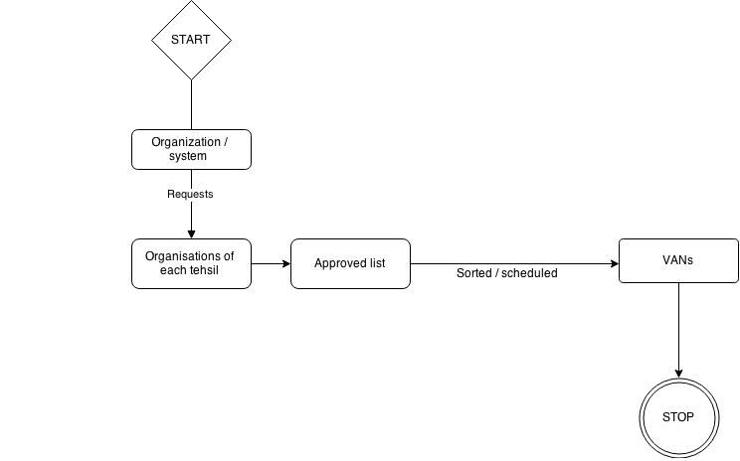

If needed, The Request to the organizations can be done by using an SMTP server. (Mailing systems)

Different entities that can be considered:

* Location
  + State
  + District
  + Division
  + Sub District/ Tehsil
* Vehicle (Blood collecting Van)
* Organizations (who agrees for the donation camp)
* Hospitals (which are collaborated with the system)
* Members
  + Doctors
  + Drivers
  + Others

NOTE: The members who are donors will be different from the one’s who actually are part of the system.

The check attributes of the database will be binary which will be helpful to check the condition of the vehicle. (If it is ready for the work of that day or not)

ER Model.

-- Relations.png

To make changes in the ER.

<https://drive.draw.io/#G0BwYLEVl6yNprOXBWVU5YWXYyRWs>

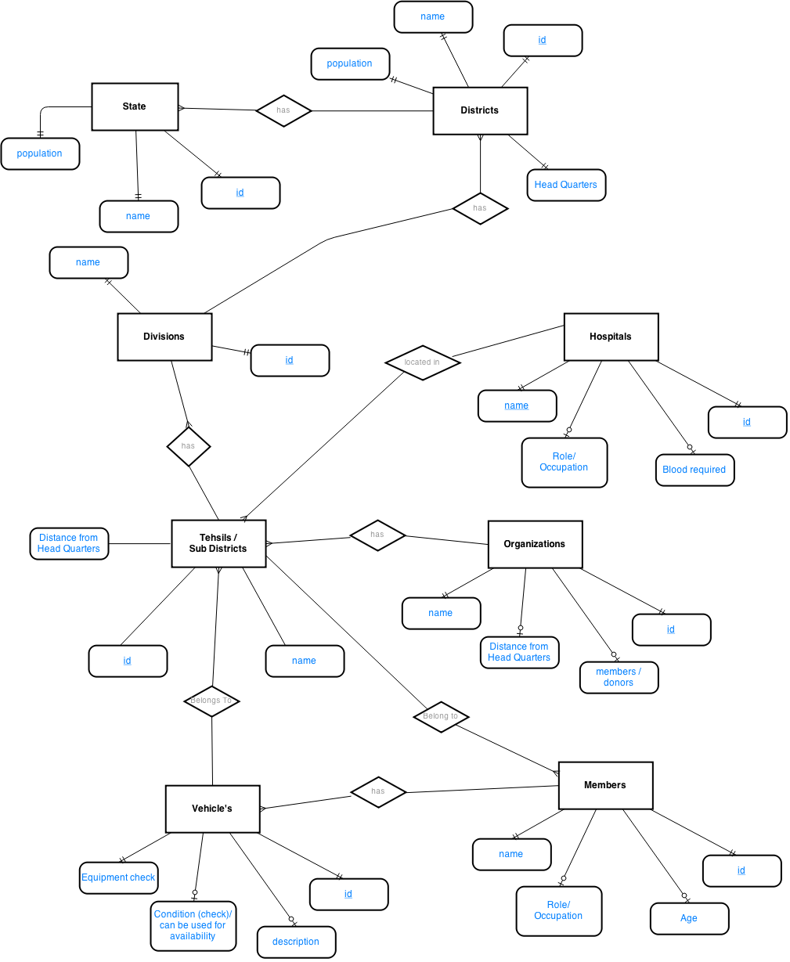

There will be three different types of people accessing the system.

* Technician in Van

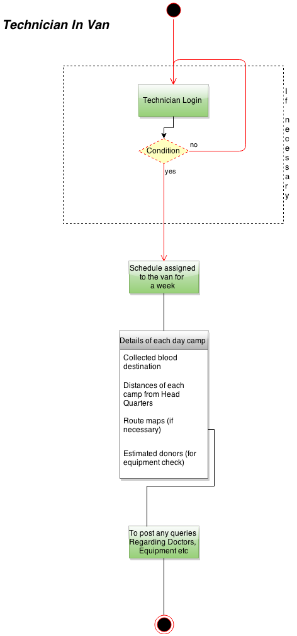

* Hospitals

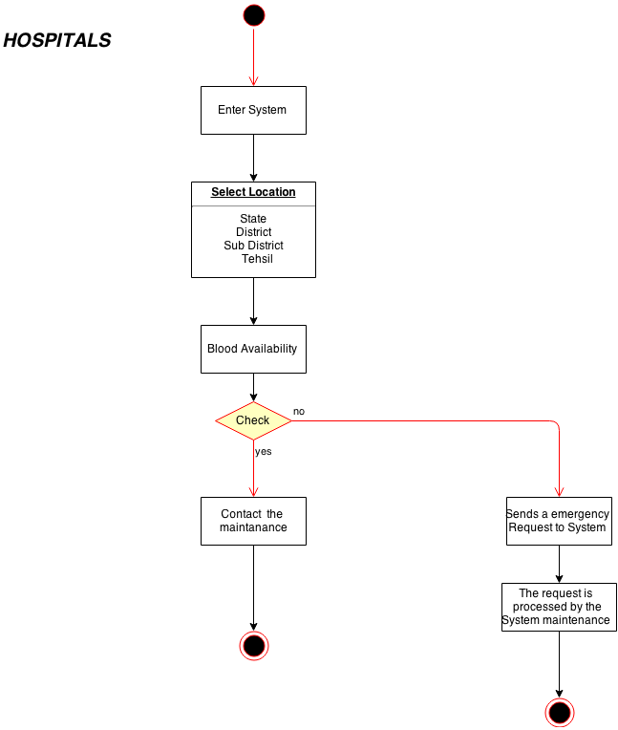

* Developers (Maintenance)

